**SECTION A-46 MARKS**

**Attempt** all **questions in this section.**

1. **Write the equation for the reaction between water and: (@01½ marks)**
2. **Ethyl ammonium chloride.**

**…………………………………………………………………………………………………………………………………………………………………………………………………………………………………..**

1. **Phosphorous (III) chloride.**

**………………………………………………………………………………………………………………………………………………………………………………………………………………………………….**

1. **A few drops of aqueous sodium hydrogen carbonate was added to the solution in (a) (i) above, State what was observed and write equation for the reaction that took place. (02 marks)**

**………………………………………………………………………………………………………………………………………………………………………………………………………………………………………………………………………………………………………………………………………………………………………………………………………………………………………………………………………………………………**

1. **Complete the following nuclear reactions and name the particles emitted in each case. (@01½ marks)**
2. ${}_{92}^{238}U$**+ ${}_{0}^{1}n$ ${}_{93}^{239}{Pu}$**  **+ …………………………………**

**Name of particle: …………………………………………………………………………**

1. ${}_{95}^{241}{Am}$**+ ${}_{2}^{4}{He}$ ${}_{97}^{243}{Bk}$**  **+ …………………………………**

**Name of particle: …………………………………………………………………………**

1.  ${}_{14}^{27}{Si}$ ${}_{13}^{27}{Al}$**+ …………………………………**

**Name of particle: …………………………………………………………………………**

1. **The mass of a radioisotope, G reduced by 32% in 40 days. Calculate the half-life of radioisotope, G. (02½ marks)**

**………………………………………………………………………………………………………………………………………………………………………………………………………………………………………………………………………………………………………………………………………………………………………………………………………………………………………………………………………………………………………………………………………………………………………………………………………………………………………………………………………………………………………………………………………………………………………………………………………………………………………………………………………………………………………….**

1. **Cr(NH3)63+ and Co(CN)42- are complexes formed when Cr3+ and Co2+ ions respectively are treated with excess aqueous ammonia and potassium thiocyanate.**
2. **Name the complexes. (01 mark)**

**…………………………………………………………………………………………………………………………………………………………………………………………………………………………………………….**

1. **State what would be observed when:**
2. **Cr3+ ions are treated with excess concentrated ammonia solution. (01½ marks)**

**…………………………………………………………………………………………………………………………………………………………………………………………………………………………………..**

1. **Co2+ ions are treated with excess concentrated hydrochloric acid. (01 mark)**

**…………………………………………………………………………………………………………………………………………………………………………………………………………………………………..**

1. **Write equation (s) for the reaction(s) that takes place in (b) (i). (02 marks)**

**………………………………………………………………………………………………………………………………………………………………………………………………………………………………………………**

1. **Steam distillation is one of the methods used for the separation of a component from a liquid mixture. State two requirements for the component to be separated by steam distillation. (02 marks)**

**…………………………………………………………………………………………………………………………………………………………………………………………………………………………………………………………**

1. **A mixture containing a substance, X was distilled at 760mmHg and 98ᵒC. The distillate contained 85% by mass of water. If the saturated vapour pressure of water is 734mmHg at 98ᵒC. Calculate the molar mass of substance, X. (03 marks)**

**………………………………………………………………………………………………………………………………………………………………………………………………………………………………………………………………………………………………………………………………………………………………………………………………………………………………………………………………………………………………………………………………………………………………………………………………………………………………………………………………………………………………………………………………………………………………………………………………………………………………………………………………………………………………………………………………………………………………………………………………………………………………………..**

1. **The molecular formula of a compound, R is C3H6O. Compound, R forms a yellow precipitate with Brady’s reagent.**
2. **Write the structural formulae and names of all the possible isomers of compound, R. (02 marks)**

**………………………………………………………………………………………………………………………………………………………………………………………………………………………………………………………………………………………………………………………………………………………………………………………………………………………………………………………………………………………………**

1. **Compound, R reacted with iodine solution in aqueous sodium hydroxide solution to form a yellow precipitate.**
2. **Identify compound, R. (0½ mark)**

**……………………………………………………………………………………………………………………**

1. **Write equation (s) to show how you would prepare compound, R from an alkene. (02½ marks)**

**……………………………………………………………………………………………………………………………………………………………………………………………………………………………………………………………………………………………………………………………………………………………………………………………………………………………………………………………………………………………………………………………………………………………………………………………………………………………………………………………………………………………………………………………………………………………………………………………………………………………………………………**

1. **Although boron is in group (III) of the periodic table, it resembles silicon which is in group (IV) in some of its properties.**
2. **State four properties in which boron resembles silicon. (04 marks)**

**………………………………………………………………………………………………………………………………………………………………………………………………………………………………………………………………………………………………………………………………………………………………………………………………………………………………………………………………………………………………**

1. **Give one reason for the anomalous behavior of boron. (01 mark)**

**…………………………………………………………………………………………………………………………………………………………………………………………………………………………………………….**

1. **Write:**
2. **An equation for the hydrolysis of phenylamine hydrochloride when dissolved in water. (01½ marks)**

**…………………………………………………………………………………………………………………………………………………………………………………………………………………………………………**

1. **The expression for the hydrolysis constant, Kh for phenylamine hydrochloride. (01 mark)**

**………………………………………………………………………………………………………………………………………………………………………………………………………………………………………………………………………………………………………………………………………………………………**

1. **A solution containing 0.4 moles of phenylamine hydrochloride per litre has a pH of 3.8. Calculate:**
2. **The molar concentration of hydrogen, H+ ions in solution. (01½ marks)**

**…………………………………………………………………………………………………………………………………………………………………………………………………………………………………………………………………………………………………………………………………………………………………………………………………………………………………………………………………………………………………………………………………………………………………………………………………………………………………………………………………………………………………………………………………………………………………………………………………………………………………**

1. **The hydrolysis constant, Kh of phenylamine hydrochloride. (02 marks)**

**……………………………………………………………………………………………………………………………………………………………………………………………………………………………………………………………………………………………………………………………………………………………………………………………………………………………………………………………………………………………………………………………………………………………………………………………………………………………………………………………………………………………………………………………………………………………………………………………………………………………….**

1. **State giving equations what would be observed when the following pairs of substances are mixed. (@01½ marks)**
2. **CH3CH2CHO and ammoniacal silver nitrate solution.**

**Observation (s):**

**……………………………………………………………………………………………………………………………………………………………………………………………………………………………………………………………………………………………………………………………………………………………………………………..**

**Equation:**

**………………………………………………………………………………………………………………………………………………………………………………………………………………………………………………………..**

1. **Cyclohexene and alkaline potassium manganate (VII) solution.**

**Observation (s):**

**………………………………………………………………………………………………………………………………………………………………………………………………………………………………………………………………………………………………………………………………………………………………………………………**

**Equation:**

**………………………………………………………………………………………………………………………………………………………………………………………………………………………………………………………..**

1. **Phenylamine and bromine water.**

**Observation (s):**

**……………………………………………………………………………………………………………………………………………………………………………………………………………………………………………………………………………………………………………………………………………………………………………………..**

**Equation:**

**…………………………………………………………………………………………………………………………………………………………………………………………………………………………………………………………**

1. **Draw the structure and name the shape of the following compounds. (@01½ marks)**

|  |  |
| --- | --- |
| **Structure** | **Shape** |
| **PH3** |  |
| **SF4** |  |

1. **Write equation for the reaction between ammonia and aluminium chloride. (01 mark)**

**…………………………………………………………………………………………………………………………………………………………………………………………………………………………………………….**

**SECTION B-54 MARKS**

**Attempt** ANy **six questions in this section.**

1. **The standard electrode potentials for some half cells are shown below. Eϴ/Volts**
2. **Zn2+(aq) + 2e-** **Zn(s)  -0.76**
3. **SO42-(aq)+2H+(aq)+ 2e-** **SO32-(aq)+H2O(l) +0.20**
4. **Fe3+(aq) + e-** **Fe2+(aq) +0.77**
5. **Br2(aq) + 2e-** **2Br-(aq) +1.07**
6. **Cr2O72-(aq)+14H+(aq)+6e-****2Cr3+(aq)+7H2O(l) +1.33**
7. **Cl2(g) + 2e-** **2Cl-(aq) +1.36**
8. **MnO4-(aq)+8H+(aq)+5e-** **Mn2+(aq) + 4H2O(l) +1.52**
9. **State what would be observed and write equation for the reaction that would take place if half-cells. (@01½ marks)**
10. **A and E are connected.**

**Observation (s):**

**………………………………………………………………………………………………………………………………………………………………………………………………………………………………………………………………………………………………………………………………………………**

**Equation:**

**………………………………………………………………………………………………………………………………………………………………………………………………………………………………**

1. **B and G are connected.**

**Observation (s):**

**………………………………………………………………………………………………………………………………………………………………………………………………………………………………………………………………………………………………………………………………………………**

**Equation:**

**………………………………………………………………………………………………………………………………………………………………………………………………………………………………**

1. **Calculate the e.m.f of the cell in (a) (i) above. (01½ marks)**

**…………………………………………………………………………………………………………………………………………………………………………………………………………………………………………………………………………………………………………………………………………………………….**

1. **Explain why hydrochloric acid is not used to acidify titrants in volumetric analysis involving potassium manganate (VII) solution. (02½ marks)**

**………………………………………………………………………………………………………………………………………………………………………………………………………………………………………………………………………………………………………………………………………………………………………………………………………………………………………………………………………………………………………………………………………………………………………………………………………..**

1. **Write the cell convection when half cells C and D are combined. (02 marks)**

**………………………………………………………………………………………………………………………………………………………………………………………………………………………………………..**

1. **State what was observed and write equation for the reaction that would take place when:**
2. **Carbon dioxide gas is bubbled through a solution of potassium manganate (VII) solution. (02½ marks)**

**Observation (s):**

**…………………………………………………………………………………………………………………………………………………………………………………………………………………………………………………………………………………………………………………………………………………………….**

**Equation:**

**………………………………………………………………………………………………………………………………………………………………………………………………………………………………………..**

1. **Concentrated hydrochloric acid is added drop wise until in excess to aqueous copper (II) sulphate solution. (02½ marks)**

**Observation (s):**

**…………………………………………………………………………………………………………………………………………………………………………………………………………………………………………………………………………………………………………………………………………………………….**

**Equation:**

**………………………………………………………………………………………………………………………………………………………………………………………………………………………………………..**

1. **Ethyne is bubbled through ammoniacal copper (II) chloride solution. (02 marks)**

**Observation (s):**

**……………………………………………………………………………………………………………………………………………………………………………………………………………………………………………………………………………………………………………………………………………………………..**

**Equation:**

**………………………………………………………………………………………………………………………………………………………………………………………………………………………………………..**

1. **Hydrogen peroxide is added to acidified potassium manganate (VII) solution. (02 marks)**

**Observation (s):**

**…………………………………………………………………………………………………………………………………………………………………………………………………………………………………………………………………………………………………………………………………………………………….**

**Equation:**

**……………………………………………………………………………………………………………………………………………………………………………………………………………………………………….**

1. **A gaseous hydrocarbon, P contains 90% carbon. The density of hydrocarbon, P is 1.785 x 10-3g/cm3 at s.t.p. Determine:**
2. **Empirical formula of hydrocarbon, P. (03 marks)**

**……………………………………………………………………………………………………………………………………………………………………………………………………………………………………………………………………………………………………………………………………………………………………………………………………………………………………………………………………………………………………………………………………………………………………………………………………………………………………………………………………………………………………………………………………………………………………………………………………………**

1. **Molecular formula of hydrocarbon, P. (02½ marks)**

**……………………………………………………………………………………………………………………………………………………………………………………………………………………………………………………………………………………………………………………………………………………………………………………………………………………………………………………………………………………………………………………………………………………………………………………………………………………………………………………………………………………………………………………………………………………………………………………………………………**

1. **Hydrocarbon, P forms a white precipitate with ammoniacal silver nitrate solution. Identify hydrocarbon, P. (01 mark)**

**………………………………………………………………………………………………………………………………………………………………………………………………………………………………………..**

1. **Using equations only, show how hydrocarbon, P can be synthesized from propanoic acid. (03 marks)**

**………………………………………………………………………………………………………………………………………………………………………………………………………………………………………………………………………………………………………………………………………………………………………………………………………………………………………………………………………………………………………………………………………………………………………………………………………………………………………………………………………………………………………………………………………………………………………………………………………………………………………………….**

1. **Explain the term molar conductivity of an electrolyte. (01 mark)**

**………………………………………………………………………………………………………………………………………………………………………………………………………………………………………………………………………………………………………………………………………………………………………………………………………………………………………………………………………………………………………………….**

1. **Sketch a graph to show the variation of conductivity of a strong electrolyte with infinite dilution. (02 marks)**

**………………………………………………………………………………………………………………………………………………………………………………………………………………………………………………………………………………………………………………………………………………………………………………………………………………………………………………………………………………………………………………………………………………………………………………………………………………………………………………………………………………………………………………………………………………………………………………………………………………………………………………………………………………………………………….**

1. **Briefly explain the shape of the graph in (b) above. (02½ marks)**

**…………………………………………………………………………………………………………………………………………………………………………………………………………………………………………………………………………………………………………………………………………………………………………………………………………………………………………………………………………………………………………………………………………………………………………………………………………………………………………………………………………………………………………………………………………………………………………………………………………………………………………………………………………………………………………………………………………………………………………………………………………………………………………**

1. **The molar conductivities of nitric acid, potassium nitrate and fluoride are 421, 145 & 129Ω-1cm2/mol respectively at infinite dilution. Calculate the:**
2. **Molar conductivity of hydrofluoric acid at infinite dilution. (01½ marks)**

**……………………………………………………………………………………………………………………………………………………………………………………………………………………………………………………………………………………………………………………………………………………………………………………………………………………………………………………………………………………………………………………………………………………………………………………………………………………………………………………………………………………………………………………………………………………………………………………………………………………………………………………………………………………………………………………………………………………………………….**

1. **Dissociation constant, Ka of 0.1M hydrofluoric acid solution.[Electrolytic conductivity of hydrofluoric acid = 3.15 x 10-5Ω-1cm-1] (02 marks)**

**…………………………………………………………………………………………………………………………………………………………………………………………………………………………………………………………………………………………………………………………………………………………………………………………………………………………………………………………………………………………………………………………………………………………………………………………………………………………………………………………………………………………………………………………………………………………………………………………………………………………………………………………………………………………………………………………………………………..**

1. **The elements aluminium, silicon and phosphorous belong to period 3 of the periodic table.**
2. **Write the formula of the chlorides of the elements.**

|  |  |
| --- | --- |
| **Elements** | **Formula of chloride** |
| **Aluminium** |  |
| **Silicon** |  |
| **Phosphorous** |  |

1. **State the conditions and write equations for the reaction that takes place between each element and water. (@01½ marks)**

**Aluminium.**

**……………………………………………………………………………………………………………………………………………………………………………………………………………………………………………………………………………………………………………………………………………..**

**Silicon.**

**……………………………………………………………………………………………………………………………………………………………………………………………………………………………………………………………………………………………………………………………………………..**

**Phosphorous.**

**……………………………………………………………………………………………………………………………………………………………………………………………………………………………………………………………………………………………………………………………………………..**

1. **Sodium hydrogencabonate solution was added to the solution of aluminium chloride in water. (01½ marks)**
2. **State what was observed.**

**……………………………………………………………………………………………………………………………………………………………………………………………………………………………..**

1. **Write equation for the reaction.**

**……………………………………………………………………………………………………………………………………………………………………………………………………………………………..**

1. **Explain:**
2. **The term acidic buffer. (01 mark)**

**………………………………………………………………………………………………………………………………………………………………………………………………………………………………………………………………………………………………………………………………………………………………………………………………………………………………………………………………**

1. **The mechanism of action of an acidic buffer. (03 marks)**

**……………………………………………………………………………………………………………………………………………………………………………………………………………………………………………………………………………………………………………………………………………………………………………………………………………………………………………………………………………………………………………………………………………………………………………………………………………………………………………………………………………………………………………………………………………………………………………………………………………**

1. **Calculate the pH of a solution formed by mixing 80.0cm3 of 0.1M sulphuric acid with 120.0cm3 of 0.1M potassium hydroxide solution. (05 marks)**

**…………………………………………………………………………………………………………………………………………………………………………………………………………………………………………………………………………………………………………………………………………………………………………………………………………………………………………………………………………………………………………………………………………………………………………………………………………………………………………………………………………………………………………………………………………….**

1. **In the extraction of zinc from its ores, the ore is first concentrated and then roasted in air. The roasted material is mixed with coke and limestone, heated by hot air in a blast furnance producing zinc.**
2. **Write the name of the ore from which zinc can be extracted. (0½ mark)**

**…………………………………………………………………………………………………………………….**

1. **Describe the process by which the ore named in (a) can be concentrated. (02 marks)**

**…………………………………………………………………………………………………………………………………………………………………………………………………………………………………………………………………………………………………………………………………………………………………………………………………………………………………………………………………………………………………………………………………………………………………………………………………………………………………………………………………………………………………………………………………………….**

1. **Write equation for the reaction: (@01 mark)**
2. **Takes place when the ore is roasted in air.**

**……………………………………………………………………………………………………………………………………………………………………………………………………………………………………**

1. **Leads to the formation of zinc in the blast furnace.**

**……………………………………………………………………………………………………………………………………………………………………………………………………………………………………**

1. **State what would be observed and write equation for the reaction when zinc metal is added to:**
2. **Copper (II) sulphate solution. (02½ marks)**

**Observation (s):**

**………………………………………………………………………………………………………………………………………………………………………………………………………………………………………………………………………………………………………………………………………………………**

**Equation:**

**……………………………………………………………………………………………………………………………………………………………………………………………………………………………………**

1. **Aqueous sodium hydroxide solution. (02 marks)**

**Observation (s):**

**………………………………………………………………………………………………………………………………………………………………………………………………………………………………………………………………………………………………………………………………………………………**

**Equation:**

**……………………………………………………………………………………………………………………………………………………………………………………………………………………………………**

1. **Write equations to show how the following compounds can be synthesized. Indicate conditions for the reactions.**
2. **CH3CH2NH2 from ethanoic acid. (03½ marks)**

**…………………………………………………………………………………………………………………………………………………………………………………………………………………………………………………………………………………………………………………………………………………………………………………………………………………………………………………………………………………………………………………………………………………………………………………………………………………………………………………………………………………………………………………………………………………………………………………………………………………………………………………………………………………………………………………………………………………………………………………………….**

1. **CH3CH2COOH from bromoethane. (02 marks)**

**…………………………………………………………………………………………………………………………………………………………………………………………………………………………………………………………………………………………………………………………………………………………………………………………………………………………………………………………………………………………………………………………………………………………………………………………………………………………………………………………………………………………………………………………………………….**

1. **from nitrobenzene. (03½ marks)**

**…………………………………………………………………………………………………………………………………………………………………………………………………………………………………………………………………………………………………………………………………………………………………………………………………………………………………………………………………………………………………………………………………………………………………………………………………………………………………………………………………………………………………………………………………………………………………………………………………………………………………………………………………….**

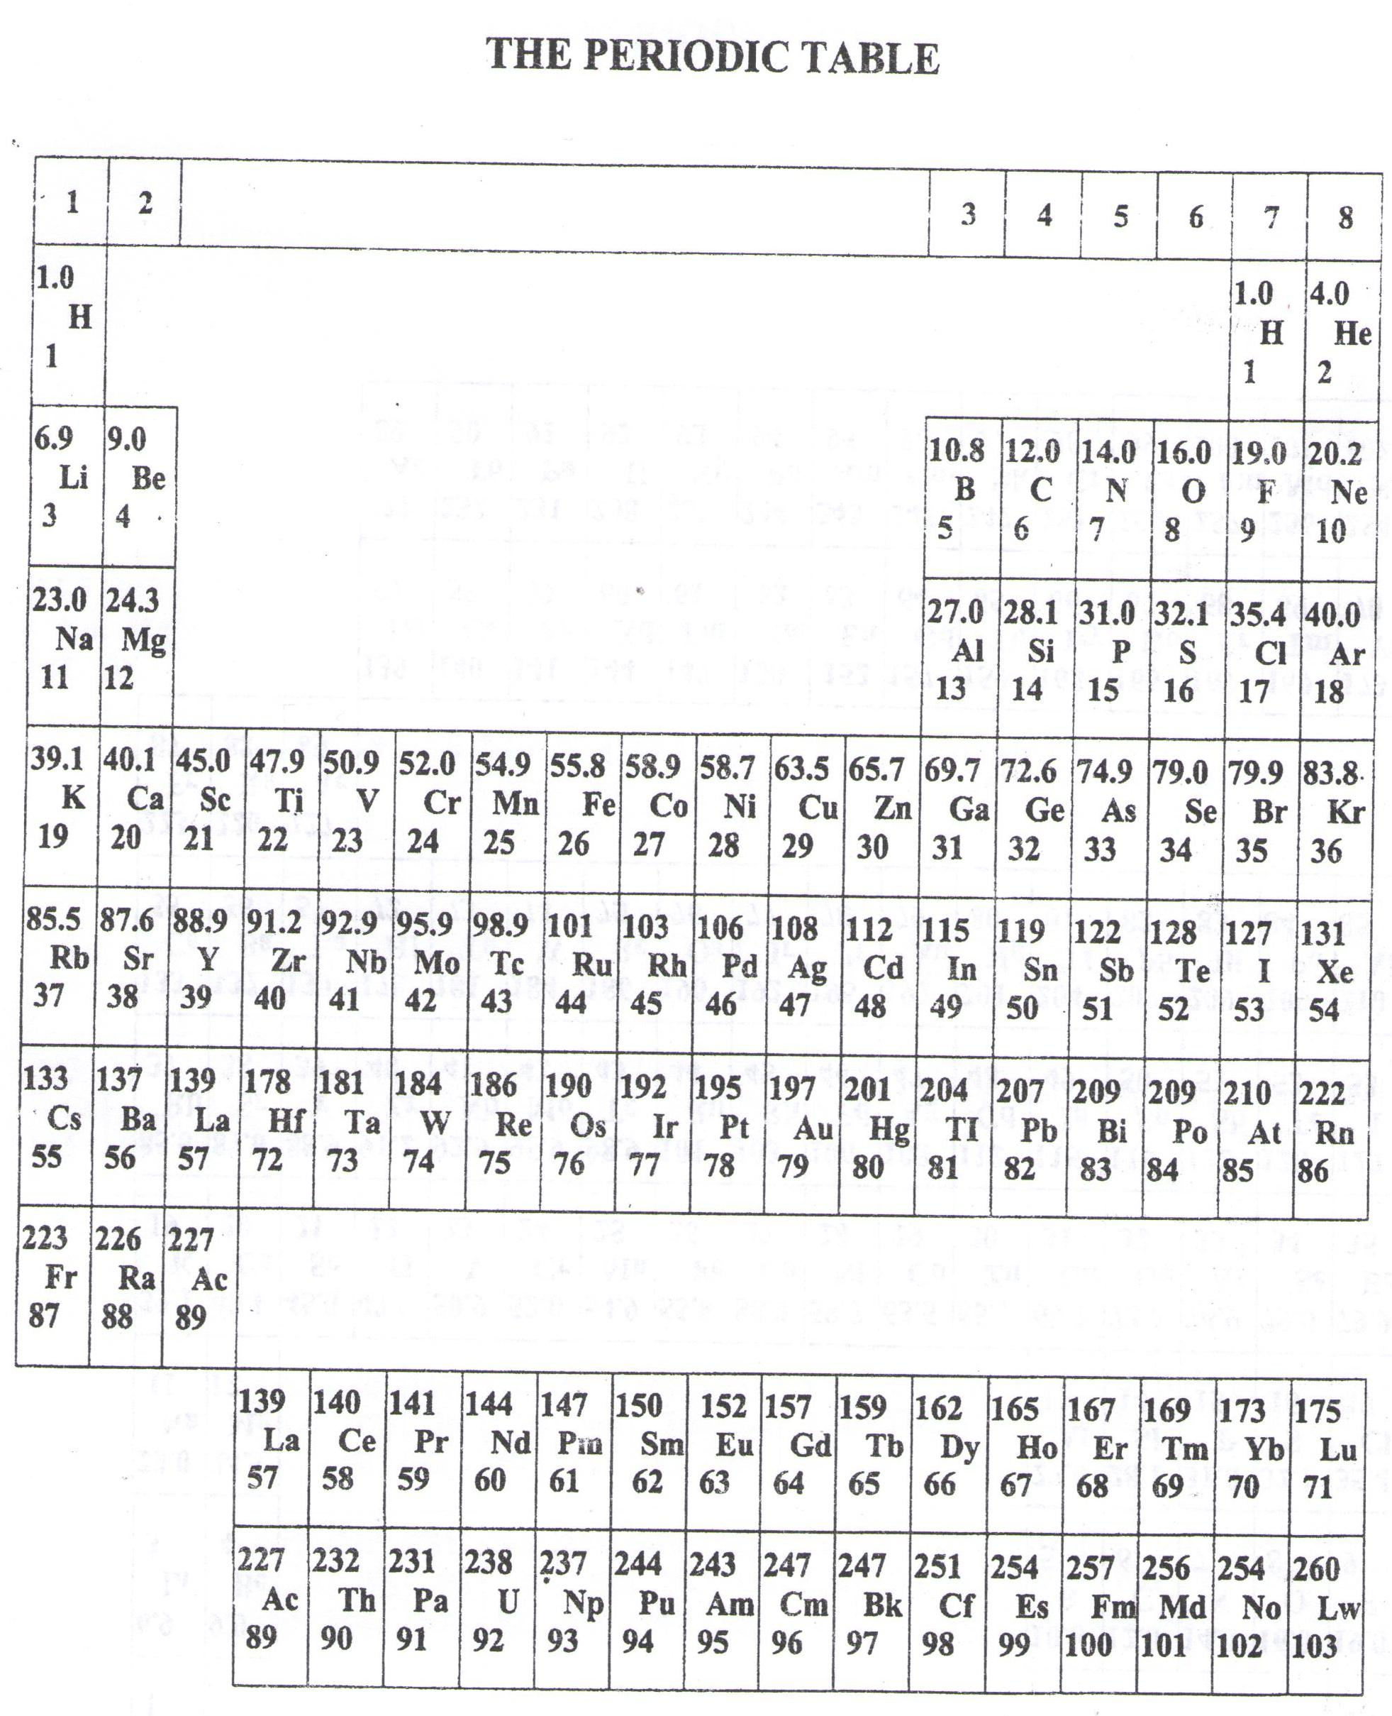

* ===END===

WELCOME TO SENIOR SIX, YEAR 2023

This is the last page of the printed paper, Page 21